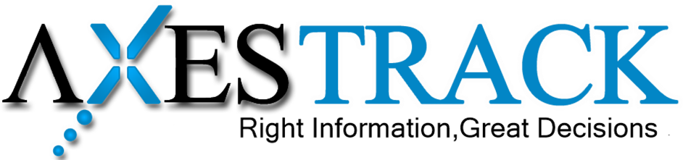

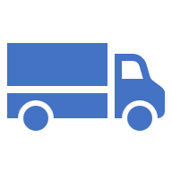

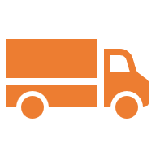

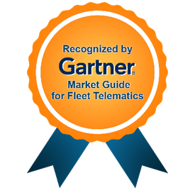

Ashok LeyLand
Technical Proposal Document

Corporate HQ
Axestrack Software Solutions Pvt. Ltd.,
Office No.-19, 6th Floor, Jaipur Electronic Market, Near Riddhi Siddhi,
Gopalpura bypass, Jaipur – 302018, Rajasthan, India
Submitted on – November 18, 2025
Table of Contents
1. Respondent Information 2
1.1 Axestrack Overview 2
1.2 Axestrack Expertise & Recognitions 3
1.2.1 Going beyond real-time visibility (unified platform for logistics) 3
1.2.2 Recognized by analysts 5
1.2.3 Stability with scale 6
2 Business Requirements 7
2.1 Business Need and Why? 7
2.2 Solution Alignment to Deliver Value 7
3 Axestrack’s – Technical Specs and Feature Note 8
3.1 Core System Architecture 8
3.2 Key Technical Specifications 8
3.3 Distinguishing Technical Prowess 8
4 Scope of Service 9
4.1 Functional Scope 9
4.2 Technical Scope 10
4.3 Out of Scope (Gate Operations) 10
5 Solution Overview 11
5.1 Solution Alignment 11
5.2 Phase-Wise Approach 12
5.2.1 Phase 1 – Readily Deployable Solution 12
5.2.2 Phase 2 – Full-Scale Plant Monitoring & TAT 12
6 Training Approach 13
7 Governance Structure 14
8 Assumptions & Dependences 15
9 Overview of Connected Plant Logistics 17
9.1 One Stop Solution for Plant logistics & Assets Visibility 17
9.2 In-plant Trip Management 17
9.3 SMART Dock & Parking Management 18
9.4 Checklist & Alerts Dashboard 18
9.5 Benefits of Axestrack Connected Plant Logistics 19
10 Pragmatic View of Product Roadmap & Innovations Planned 20

Respondent Information

Axestrack Overview
Axestrack stands as a pioneer in transforming the logistics industry with innovative solutions that redefine fleet management. With over 15 years of expertise and only Indian company ever to be recognized in Gartner’s 2024 Market Guide for Fleet Telematics Solutions, we are a trusted name for businesses seeking smarter, safer, and more efficient operations.
At the core of our offerings is the Axestrack Operating System (aOS), a next-generation AI platform designed to go beyond traditional tracking. Built on advanced analytics, intelligent automation, and real-time insights, aOS delivers comprehensive solutions to optimize fleet productivity, reduce TAT, providing end-to-end visibility and control for inbound, in-plant, outbound and port operations and improve operational efficiency. (For more about the platform please visit - https://www.axestrack.com/)
Axestrack is more than just a technology provider; we are a partner in driving innovation. Our solutions for Gate Operations (GOS), Yard Management, Logistics platform and many more brings together real-time visibility, actionable insights, and intelligent control, enabling businesses to predict, prevent, and resolve challenges before they escalate.
Our impact is far-reaching, with aOS managing over 250,000 commercial vehicles globally, for 100+ clients and enabling smarter logistics across diverse industries like Cement, Automobile, FMCG, E-commerce, Chemical, etc. Whether it’s fleet owners, consignors, plants, or port authorities, we deliver tailored solutions that drive efficiency and compliance.
Recognized globally and trusted locally, Axestrack is committed to shaping the future of logistics. We are investing in advanced telematics, IoT integrations, and cloud-based control towers to ensure our clients stay ahead in an ever-evolving landscape.
With Axestrack, every journey becomes smarter, safer, and future-ready.
Few of our successful customers / references.
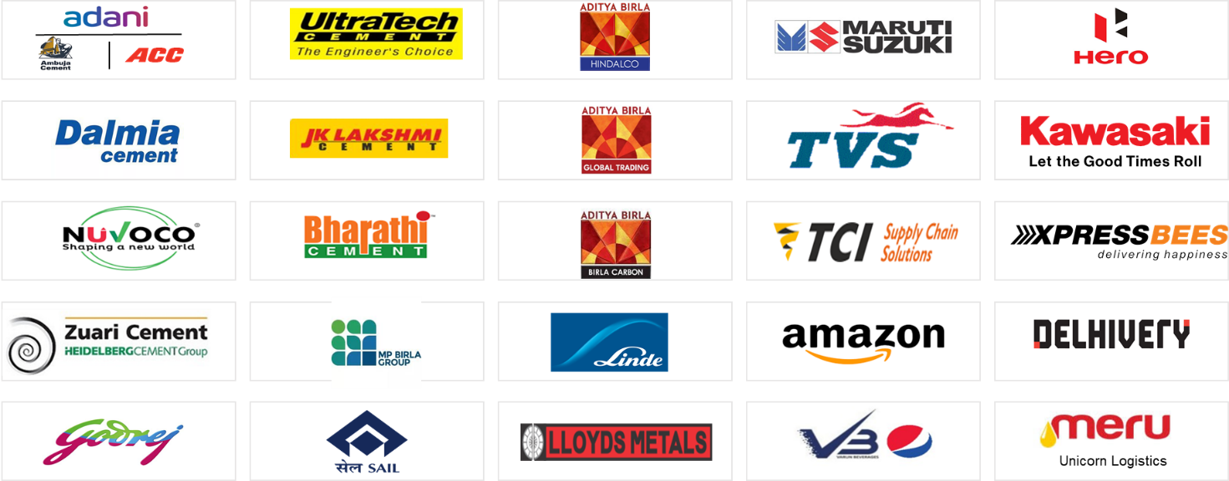

Axestrack Expertise & Recognitions

Going beyond real-time visibility (unified platform for logistics)
Axestrack with its suite of products (xSwift, Connected Port Logistics, Gen AI Based Managed Control Tower, Connected Port Logistics, etc.) provides state-of-the-art tracking and visibility to shippers and fleet owners.
The unified, single-pane view across all platforms facilitates rapid and informed decision-making. This connected operating system is structured into three key layers: See, Understand & Learn, and Act.

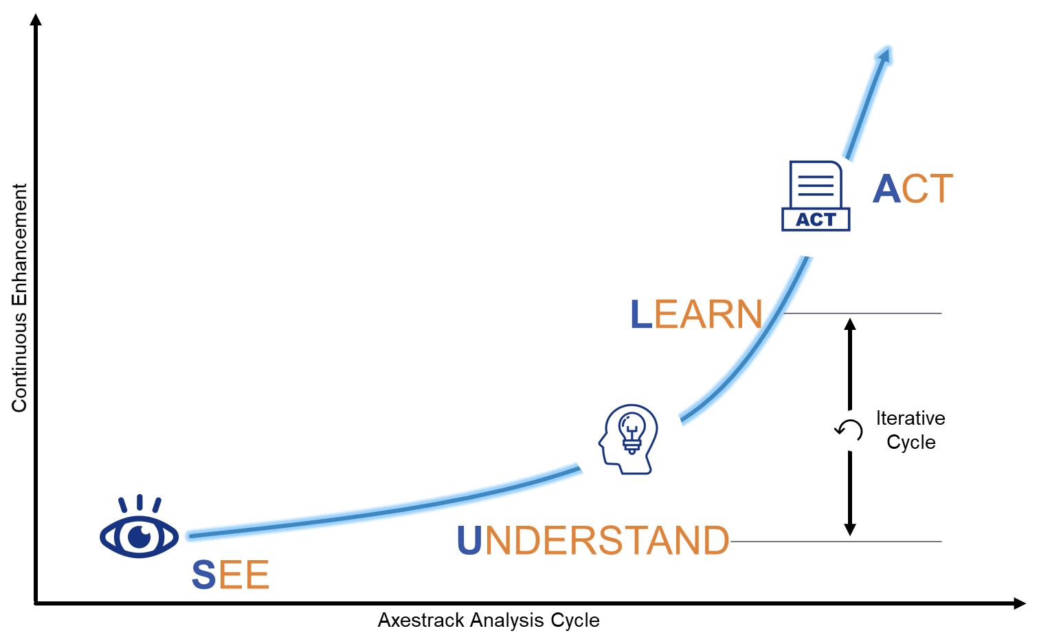
- The See layer aggregates data from multiple sources, including third-party GPS/Telematics systems, 3PL providers, TOS/ERP/TMS platforms, toll systems, government portals, OEM systems, third-party SIMs, and open APIs. This data is consolidated into a comprehensive data pool via a robust integration layer.
- The Understand & Learn layer leverages advanced AI and machine learning capabilities to transform this data lake into a data pool, enabling deeper insights and meaningful analytics.
- The Act layer presents this processed data through unified platforms, offering actionable analytics and reports. These insights empower the Managed Control Tower to make real-time interventions, ensuring efficient operations and improved outcomes.

Recognized by analysts
Axestrack has been widely recognized as a top digital solution provider through industry research, awards, and strategic partnerships. Axestrack has received numerous awards and accolades for its innovative digital solutions, including Gartner’s 2024 Market Guide for Fleet Telematics.
Axestrack believes in excellence which led our innovations and product capabilities recognized by multiple analysts and market leaders to solve transportation challenges in the industry.
According to Gartner ‘The fleet telematics market is growing, driven by the increasing demand for efficient fleet management solutions and operational optimization. This growth is catalyzed by widespread telematics adoption, supportive regulatory frameworks, reduced operational costs and enhanced customer satisfaction through real-time visibility on deliveries, driver safety and retention. The integration of AI, ML, and big data analytics is poised to propel the market forward by delivering advanced insights and predictive capabilities for fleet management.’

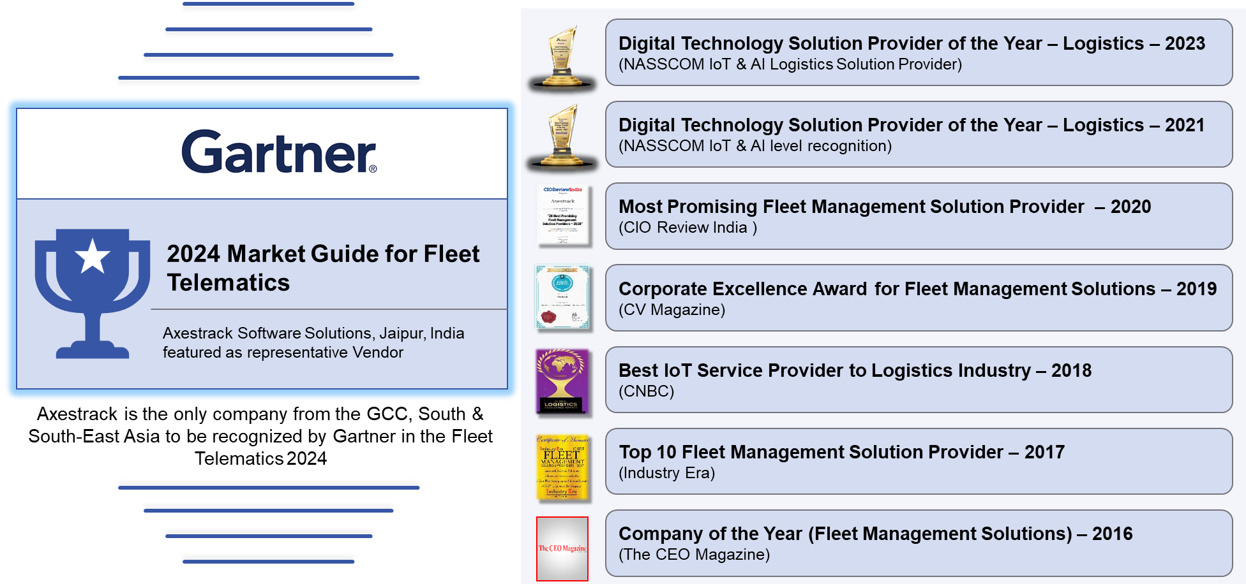

Stability with scale
At Axestrack, we go beyond being a solution provider—we are a strategic partner in port and plant digitalization. With over 15 years of expertise in logistics technology and deep industry insights, we deliver scalable, future-ready solutions that optimize port operations. Our solutions are built for high-volume, mission-critical environments managing 30+ enterprise clients.
Our in-house Center of Excellence (CoE) specializes in designing, developing, and deploying XSWIFT—a unified, cloud-native platform that integrates seamlessly with any ERP, TMS, WMS. From Proof of Concept (PoC) to full-scale deployment, XSWIFT enhances logistics movement tracking and automation, gate management, vehicle tracking, and real-time operational visibility.
As a bootstrapped, profitable organization, Axestrack ensures long-term stability, innovation, and continuous improvement in port logistics, enabling clients to achieve higher efficiency, reduced turnaround times, and seamless cargo movement within port ecosystems.
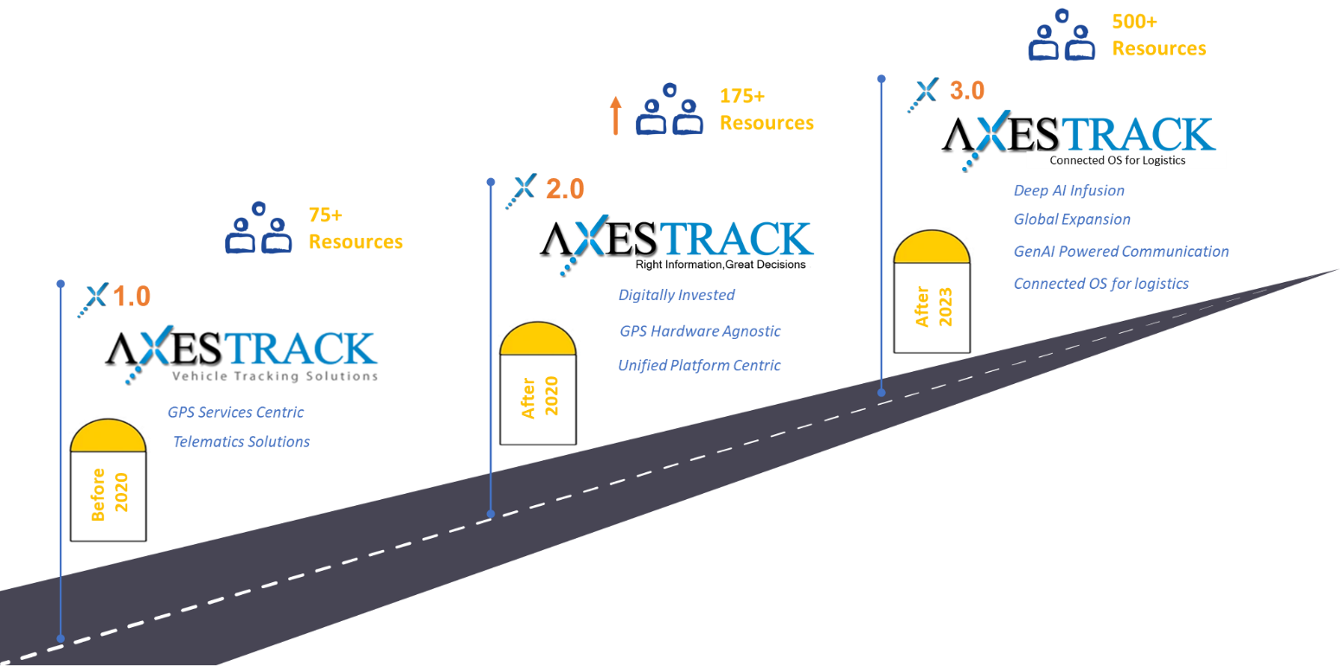

Business Requirements

Business Need and Why?
Ashok Leyland’s inbound logistics operations involve multiple fixed loading plants and unloading plants across India. While the current tracking platform provides en-route visibility of vehicles, it lacks plant-level integration for capturing gate-in and gate-out events. This creates:
- Limited visibility of TAT: No accurate timestamps of vehicle entry and exit at plants.
- Operational inefficiencies: Delay analysis is difficult without standardized TAT measurement.
- Dependence on manual records: Increases scope of errors and exceptions.
- Missed benchmarking opportunities: Plant-to-plant performance cannot be measured uniformly.
Business Need: To establish a standalone Connected Plant Logistics (CPL) solution that digitizes plant-level gate processes, integrates with existing Tracking Partner, and provides real-time monitoring of inbound vehicles TAT to enhance visibility, efficiency, and accountability across 8 Ashok Leyland plants

Solution Alignment to Deliver Value
Axestrack’s Connected Plant Logistics (CPL) platform will serve as a digital layer that complements existing vehicle tracking.
How the solution aligns with Ashok Leyland’s requirements:
- Real-time Gate Digitization
- Deploy RFID/FASTag/ANPR-enabled checkpoints at gate-in and gate-out.
- Capture accurate entry/exit timestamps without manual intervention.

- Integration with Grow System (API)
- Vehicle master and inbound trip details fetched automatically.
- Avoids duplication of effort and ensures a single version of truth.

- Centralized TAT Computation
- Automatic calculation of TAT from loading plant exit → unloading plant entry.
- Plant-to-plant and stage-wise tracking enabled.

- Visibility & Analytics Dashboards
- Role-based access for Plant Operations, SCM, and Central Teams.
- Daily/weekly/monthly TAT performance reports for benchmarking.

- Readily Deployable Infrastructure
- Tablets with SIMs at each gate to ensure connectivity.
- RFID reader deployment for seamless automation.
Value Delivered:
- Improved visibility and control of inbound movement.
- Standardized TAT monitoring across all plants.
- Accountability in operations with data-driven insights.
- Scalable foundation for yard management, ERP integration, and AI-driven analytics

Axestrack’s – Technical Specs and Feature Note

Core System Architecture
Layer | Key Feature | Technical Value
Edge Layer | Axestrack AT Controller (ATC01): IoT-enabled PLC controller | Removes third-party dependency; ensures fail-safe operation at gate level.
Device Layer | Industrial-grade devices: RFENERGIE, Chainway | IP52–IP65 rated; ensures 24×7 uptime in harsh conditions.
Integration Layer | Secure APIs for ERP (Infor LN), ULIP, VAHAN, SARATHI | Ready API integration for real-time compliance checks.
Platform Layer | Axestrack CPL: Cloud-native microservices on AWS | 99.9% uptime; ISO 27001 & IEC 62443 certified; modular scalability.

Key Technical Specifications
Component | Make & Model | Technical Highlights | Axestrack Advantage
RFID Reader | RFENERGIE HR15 | UHF 865–868 MHz, 15 m range | Accurate multi-tag detection, integrated with CPL
Industrial Tablet | Chainway P80 | 8" FHD, Android 13, IP65 | Digital checklists & e-sign integrated with ERP
Software Platform | Axestrack CPL | AWS, ISO 27001, IEC 62443 | Cloud-native, scalable, and secure

Distinguishing Technical Prowess
- Full hardware-software ownership (no third-party controllers or middleware).
- Edge + Cloud synergy ensuring instant gate response and central governance.
- ISO 27001, IEC 62443, VAPT certifications ensuring enterprise-grade security.
- Proven integration readiness with Infor LN, ULIP, VAHAN, and SARATHI APIs.
- Ruggedized design and local fail-safe logic ensure 99.9% uptime even in network outages.

Scope of Service

Functional Scope
The CPL solution will digitize and automate all inbound and outbound gate operations across Ashok Leyland’s 8 plants.
- Automated Vehicle Identification:
- Each vehicle is identified at entry/exit using RFID tags / FASTag ID / ANPR.
- Tag data cross-verified against the vehicle master in CPL platform.
- ULIP based verification for the RC/PUC/Insurance

- Gate-In & Gate-Out Timestamping:
- Automatic logging of date & time when vehicle enters or exits the plant gate.
- No manual entry required, reducing human error.

- TAT Computation at Gate Level:
- Exit timestamp from loading plant → Entry timestamp at unloading plant.
- Gate-wise performance metrics consolidated into overall Plant-to-Plant TAT.

- Exception Handling:
- Vehicles without valid RFID/FASTag/ANPR match flagged for manual verification.

- Role-Based Gate Dashboard:
- Security team: Gate event verification.
- Plant operations: Queue monitoring, vehicle turnaround reports.
- Central SCM team: Consolidated visibility across all plants.

- MIS & Audit Trail:
- Exception log (vehicles entered/exited without valid tags).
- Audit trail for compliance and dispute resolution.

Technical Scope
- Hardware & Integration:
- Supply, installation, and commissioning of RFID readers/ ANPR Camera at gate entry/exit.
- Integration with plant IT infrastructure (power, LAN/Wi-Fi).

- Tablets with SIM Cards:
- Tablets provided at each gate to record gate events.
- Mobile network data plan included for seamless connectivity.

- Software Integration:
- CPL platform linked with Tracking Platform via API (maximum 3 APIs) for vehicle master/trip details.
- Local gate device data synced in real-time with CPL cloud platform.

- Data Flow & Processing:
- Gate device → CPL middleware → Cloud platform → Dashboard/MIS.
- Automated alerts pushed via email/WhatsApp/IVR in case of anomalies.

- Security & Access Control:
- Role-based login access for gate operators, plant managers, and central teams.
- Encrypted data transmission between gate hardware and CPL cloud.

Out of Scope (Gate Operations)
- Yard/Weighbridge/Dock operations – covered under Phase 2 expansion.
- Civil infrastructure work (pole mounting, trenching, enclosures, LAN cabling, electrical) – to be facilitated by Ashok Leyland.
- GPS/Telematics tracking – handled by existing Tracking Partner
- Non-inbound vehicle tracking – e.g., visitor or contractor vehicles unless tagged separately.

Solution Overview
Ashok Leyland requires a digital solution to capture accurate inbound Turnaround Time (TAT) between fixed loading and unloading plants. While the existing tracking partner provides en-route visibility, it lacks plant-level visibility at gate entry and exit points.
Axestrack’s Connected Plant Logistics (CPL) platform addresses this gap by deploying gate automation infrastructure (RFID/ANPR), integrating with the tracking partner (via API), and providing a centralized TAT visibility dashboard. The system will serve as a standalone, scalable layer that ensures real-time monitoring, analytics, and future integration with ERP and advanced yard management systems.

Solution Alignment
The proposed CPL solution aligns with Ashok Leyland’s objectives in the following ways:
- Accurate Gate Digitization – Automated capture of gate-in and gate-out timestamps using RFID/FASTag and ANPR cameras.
- Integration with Tracking Partner – API connectors ensure inbound trip and vehicle details are seamlessly linked.
- Centralized TAT Visibility – Plant-to-plant TAT computed automatically, visible in real-time dashboards.
- Exception Handling – Hybrid approach (RFID + ANPR) reduces dependency on third-party data availability and minimizes manual interventions.
- Scalability – Phase 1 lays a quick foundation, while Phase 2 builds advanced functionality (yard, ERP, AI-driven predictions).
- Business Value Delivered – Standardized performance monitoring, improved accountability, operational efficiency, and readiness for digital transformation.

Phase-Wise Approach

Phase 1 – Readily Deployable Solution
Quick implementation of gate-level automation for TAT capture across 8 plants (Ennore, Hosur 1, Hosur 2, Alwar, Pantnagar, Bhandara, ALFD Ennore, ALFD Sriperumbudur).

Option 1 – RFID Reader Based
- RFID readers installed at entry/exit gates.
- Tags linked with CPL platform for timestamping and TAT calculation.
- Straightforward, fast rollout, but dependent on RFID/tag reliability.
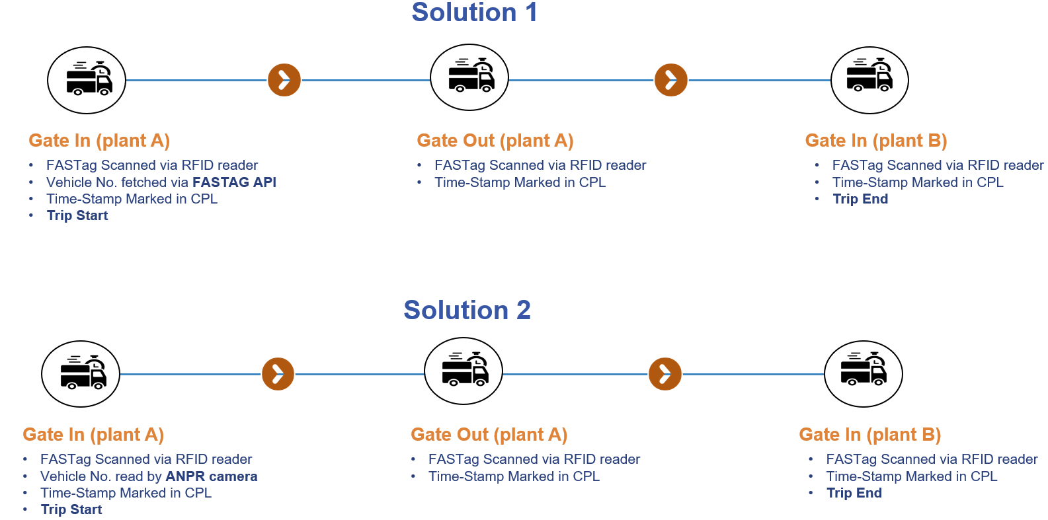

Option 2 – RFID + ANPR Camera (Recommended)
- Dual validation: RFID for tag ID + ANPR for license plate recognition.
- Reduces exceptions and dependency on external APIs.
- Higher data accuracy, future-ready foundation.

Infra in Scope: Tablets with SIMs, RFID readers, ANPR cameras (Option 2), API integration with tracking partner, CPL cloud dashboard.

Phase 2 – Full-Scale Plant Monitoring & TAT
Extend CPL beyond gate events to cover end-to-end plant operations and predictive analytics.
- Yard Management & Dock Scheduling – Queue management, automatic bay allocation.
- Stage-Wise TAT Computation – Gate In → Weighbridge → Yard → Dock → Gate Out.
- ERP Integration – SAP/Oracle integration for TAT cycle visibility.
- Advanced Analytics & AI Predictions – Predictive alerts for delays, benchmarking across plants, stage bottleneck analysis.

Training Approach
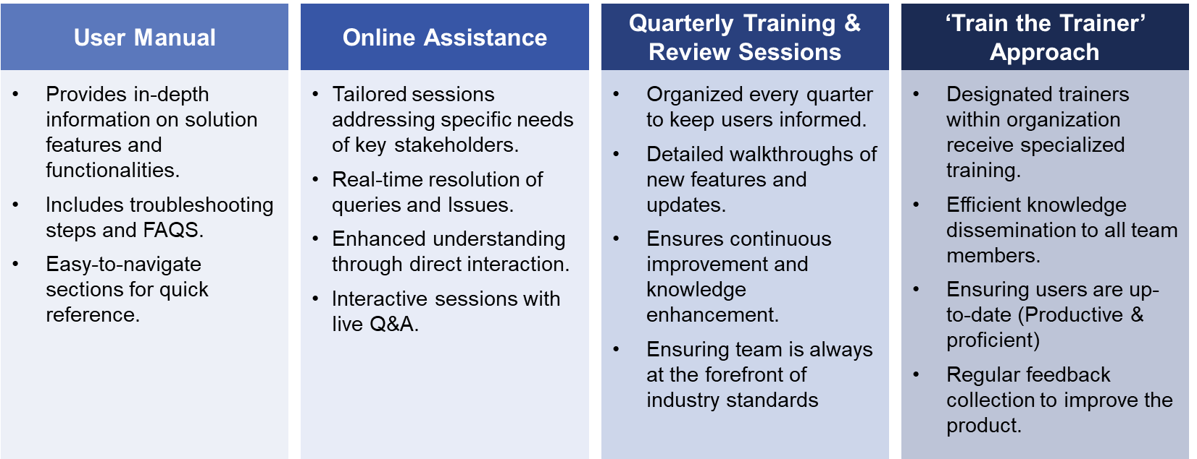

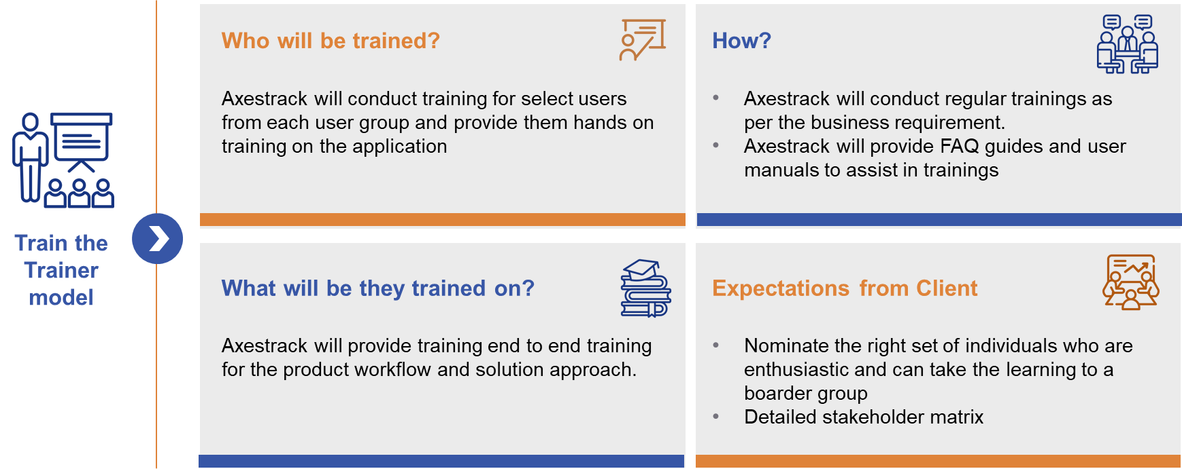

Governance Structure
Axestrack has three layered approaches to Governance
Steering committee and value board: This layer will have the executive sponsor for the project with one-to-one mapping with the Ashok Leyland’s Sponsors level management. The team will meet monthly/quarterly to validate and monitor the project progress and take strategic decisions. This layer is the highest level of escalation,
Enagament & project management: This layer provides the project level monitoring and management. They will deal with the day-to-day operation issues and escalations. This layer will be responsible for the project success and excellence.
Project operations & transformation: This layer involves all the members of execution team including Technical SPOCs, functional SPOCs and SMEs. These will interact with the client project team on daily basis and work for the success of the project.
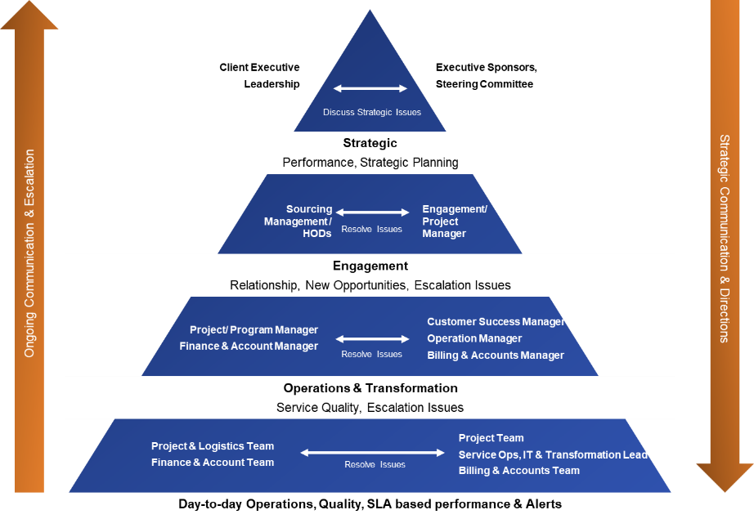

Assumptions & Dependences
Sr. No. | Assumptions | Comments
1 | Civil infrastructure readiness including trenching, power supply, LAN/Wi-Fi connectivity, and enclosures to be provided by Ashok Layland. | To be arranged and completed by Ashok Leyland prior to hardware installation by Axestrack.
2 | Uninterrupted Power Supply (UPS) to all hardware components will be provided and maintained by Ashok Leyland. | This ensures reliable hardware performance by minimizing downtime risks due to power interruptions, with Ashok Leyland handling local power management.
3 | All hardware installation will be done on client-prepared infrastructure | Axestrack will only mount and commission the hardware at defined locations.
5 | All ERP/Tracking Partner integrations will be handled through APIs (Push/Pull) | Ashok Leyland to provide API endpoints, credentials, and field mappings; up to 3 API integrations are considered under current scope.
6 | Coordination with third-party vendors and admin staff will be managed by Ashok Leyland | Required for data inputs, API handshakes, and external system interactions.
8 | Testing sign-offs (SIT & UAT) will be provided by Ashok Leyland at each project stage | Formal approval is expected to proceed with subsequent deployment phases.
9 | Train-the-Trainer approach will be used for user enablement | Ashok Leyland will nominate users who will be trained by Axestrack and will internally cascade the training.
10 | All documentation, deliverables, and training will be in English | Any local language translation support, if required, will be managed by Ashok Leyland.
11 | SaaS-based deployment model will be followed | No on-premise hosting or network support is included in scope.
12 | IT infrastructure (network, firewall, security, etc.) will be owned by Ashok Leyland | Axestrack will only provide configuration recommendations; implementation lies with Ashok Leyland IT.
13 | All required plant access, safety training, passes, and PPEs for Axestrack team to be provided by Ashok Leyland | Necessary for on-site work execution and safety compliance.
15 | Any deviation, new requirements, or environmental delays will not be considered into Axestrack’s responsibility | Such cases will be discussed and managed via formal change requests.
16 | Any additional hardware requirements beyond the agreed scope will be charged separately | Procurement and pricing to be approved through formal change management.
17 | All project deliverables will be signed off in a timely manner by the designated Ashok Leyland SPOCs | Delay in approvals may impact project timelines and delivery.
18 | Data extraction, cleansing, validation & reconciliation from ERP systems will be handled by Ashok Leyland business users | Axestrack will consume validated inputs for integration purposes only.
19 | Issues or bugs related to third-party products, services, or plugins are out of scope | Axestrack will provide guidance, but not direct resolution, for external system-related errors.

Overview of Connected Plant Logistics

One Stop Solution for Plant logistics & Assets Visibility
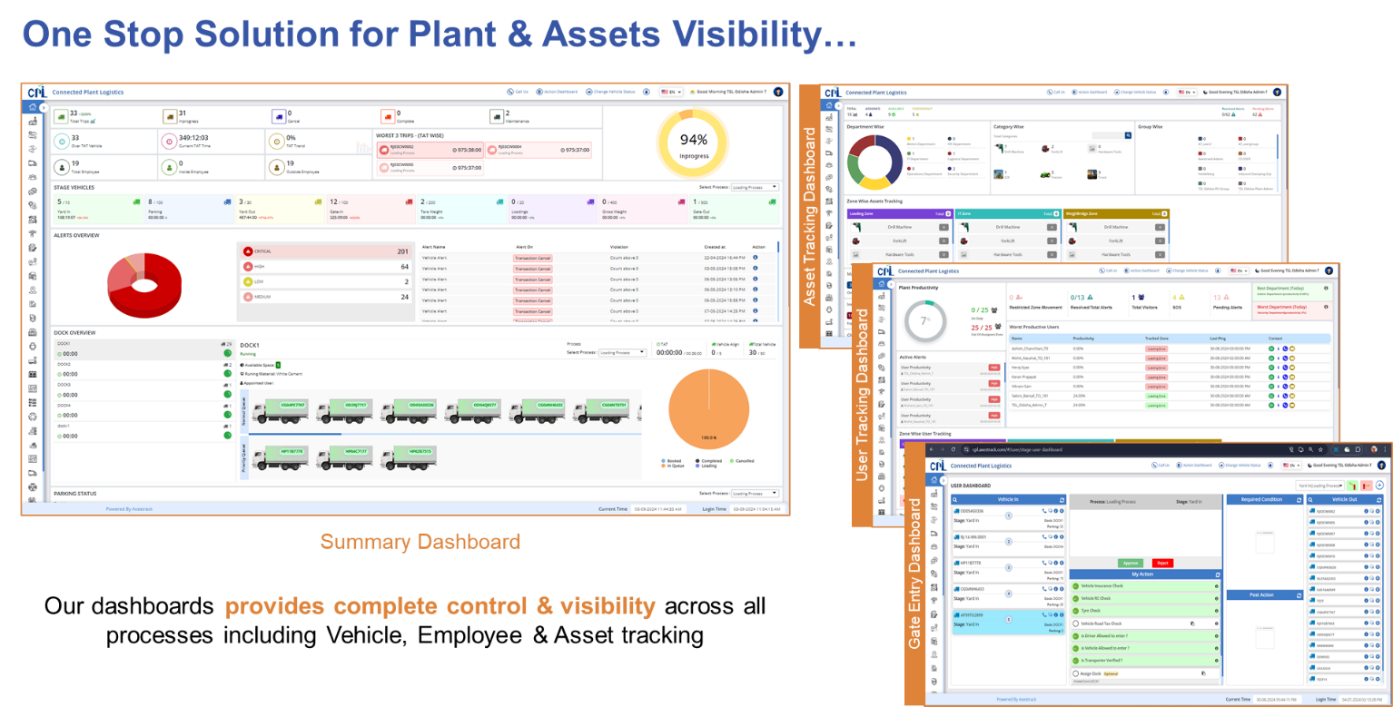

In-plant Trip Management
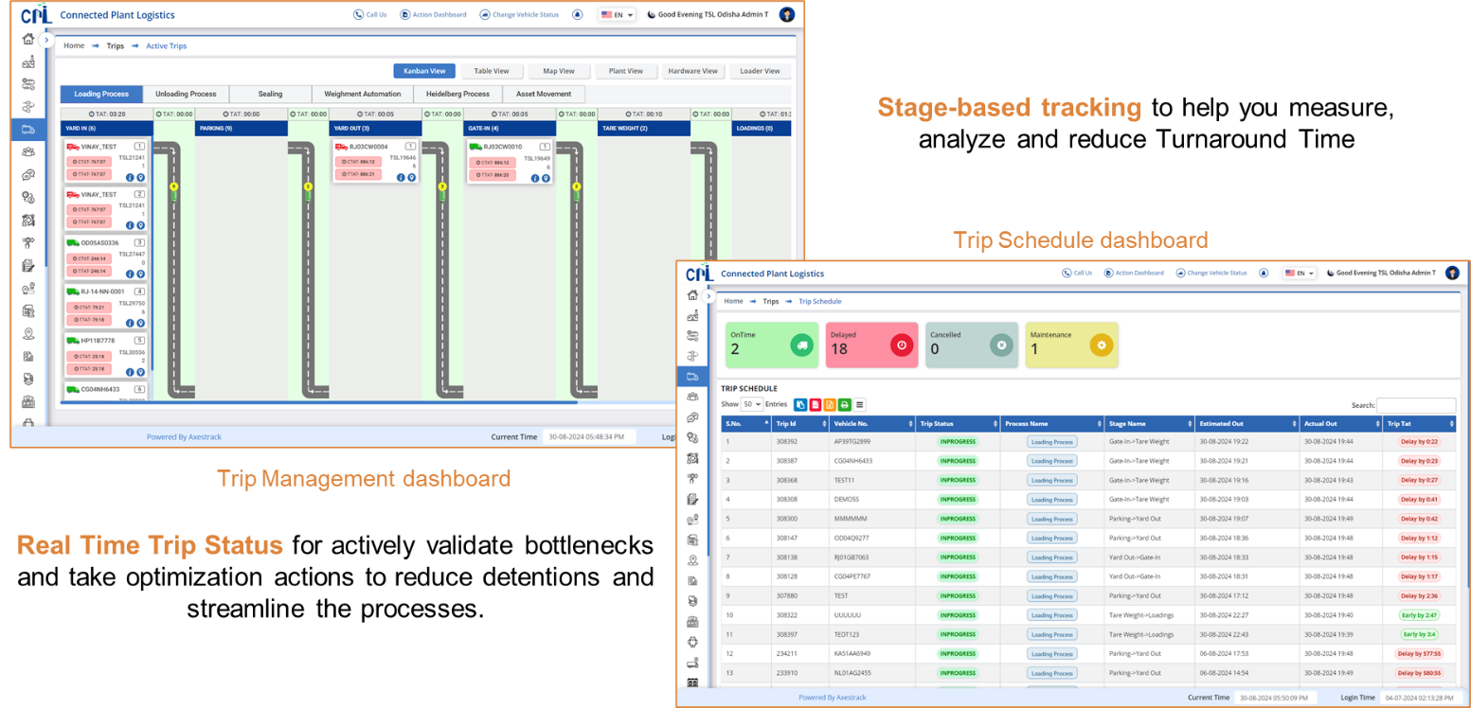

SMART Dock & Parking Management
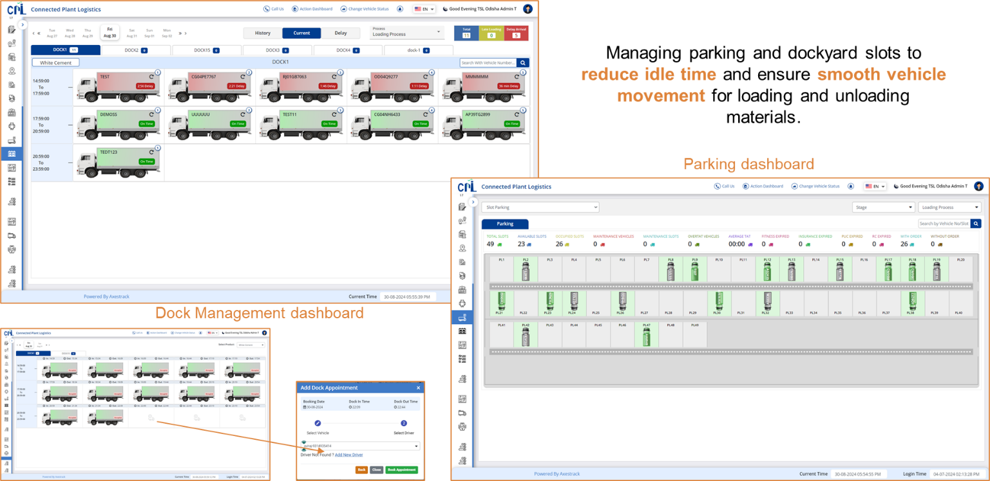

Checklist & Alerts Dashboard
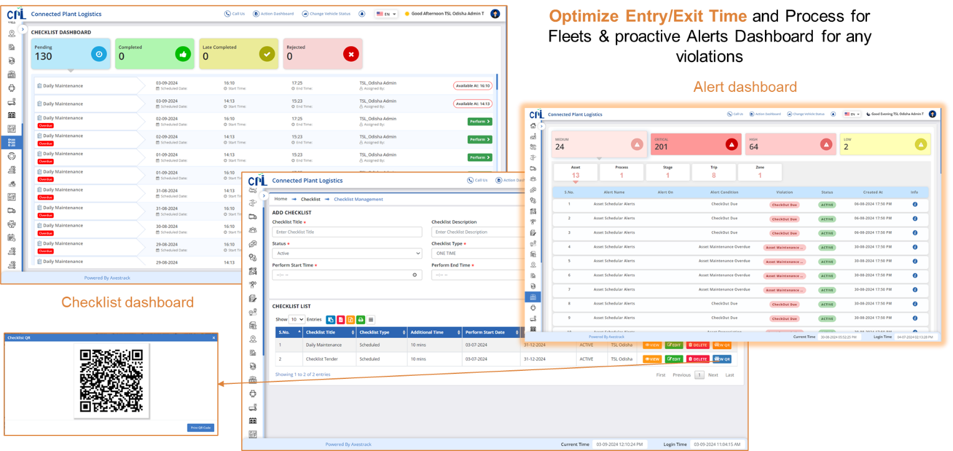

Benefits of Axestrack Connected Plant Logistics

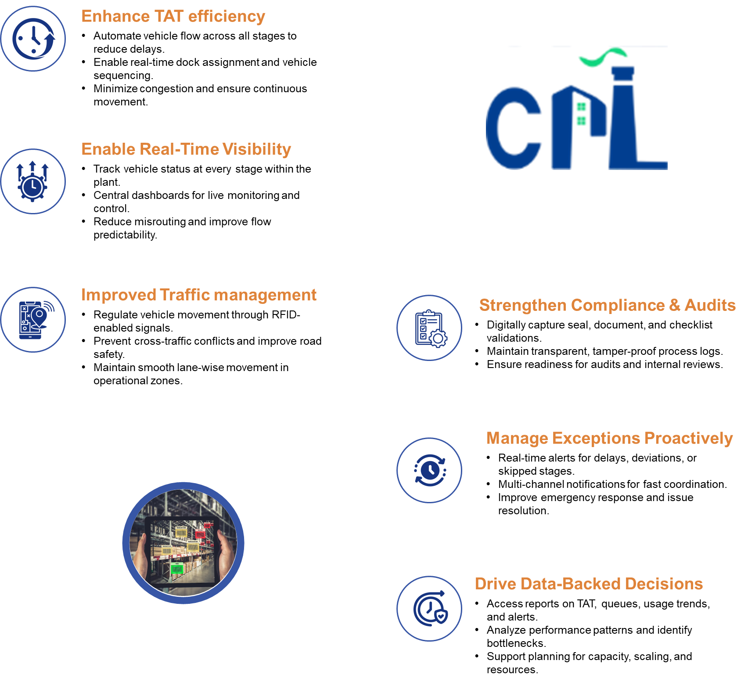

Pragmatic View of Product Roadmap & Innovations Planned
Axestrack’s product roadmap has been built keeping current and future needs of the industry in scope. The roadmap establishes our commitment to the innovations and capabilities which we co-develop with client to ensure these developments are relevant to the needs of the clients.
The intent behind this vision is simple. We understand that “connectivity” is the way for future and hence the core of any solution must embrace the connected part and should support the mechanisms which promotes connectivity.
We understand that while vision is clear, we also need to keep the structural elements flexible and modular. Hence, the design of our architecture and roadmap has been envisioned to be ‘modular and agile’.
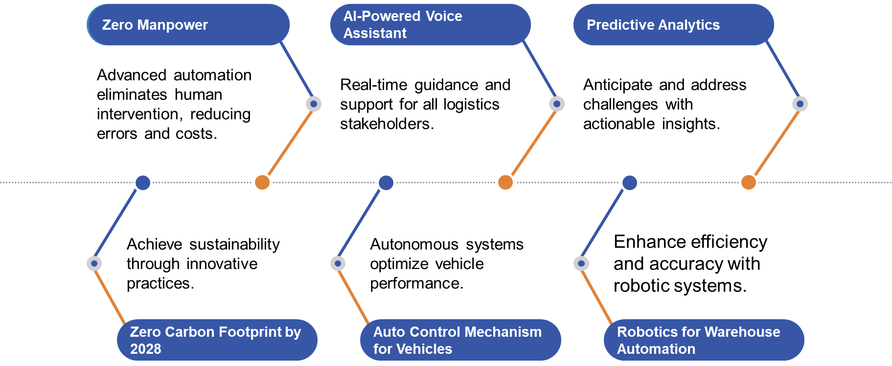


www.axestrack.com
www.

